Interface Design Document

Project Name: Titan

Project ID: 17309

Application ID: ILOS1

Interface Name: RouteInfo

Version: <0.1>
Revision History

Date | Version | Description | Author
07/25/2016 | 0.1 | Draft | Keerthi Mothukuri

Reference Documents

Instructions
Include document dependencies required for interface development. This should include relevant project documents (use cases, supplementary specifications, Software Architecture Document) as well as mapping documents, standards documents, system documents etc. Include the version and date of the referenced document and the shared location where this is available

Document Name | Version | Last updated Date | Shared Location
Project Requirements Document
Solution Architecture Document (SAD) |  |  | https://project.safeway.com/PWA/17309%20Titan/Working%20Documents/1.%20Analysis%20and%20Design/Arch%20Docs/17309%20-%20Titan%20Phase%201%20%20-%20SAD.docx
Supplemental Specification
IRD |  |  | https://project.safeway.com/PWA/17309%20Titan/Working%20Documents/1.%20Analysis%20and%20Design/IRD/TMS-DOM/RouteInfo-%20IRD.doc

Table of Contents

1. Interface Overview 3
1.1 Solution Statement 4
1.2 Design Considerations 4
1.2.1 Goals 4
1.2.2 Assumptions 4
1.2.3 Dependencies 4
1.2.4 Constraints 4
1.3 Design Decisions 5
2. Integration Design 5
2.1 High level integration design 5
2.1.1 Integration Flows 7
2.2 Detailed Component Design 7
2.2.1 Reads TMS file 7
2.2.2 EOM Web service 7
2.2.3 Transforming and creating XML file 8
2.2.4 Load to EOM queue 8
2.2.5 Reprocess reject XML 8
2.3 Mapping document 8
2.4 Error Handling Strategy 8
2.5 Security 8
2.6 Monitoring 9
3. Administration 9
3.1 Execution Strategy 9
3.2 Recovery Strategy 9
3.3 Housekeeping Strategy 9

Interface Overview

Solution Statement

This Interface updates the Order delivery confirmation (with the “route and stop” information) pertaining to each order in Order management system from TMS application. Interface uses the delivery manifest XML file created by the TMS application to get the delivery confirmation and updates it in order management system for each store and each delivery shift.

Design Considerations

Goals
The Route Info Interface transfers the order route information from TMS to Manhattan application once the delivery manifest files are created by TMS.

Assumptions
Assumption | Description
RouteInfo for each store | One file will contain the routes for all the orders that are delivered for a single shift.
Input file created by TMS | The Delivery Manifest files for each store have to be created successfully in TMS environment.
FTP of the files from TMS to Datastage | The FTP process from TMS environment to the DS environment at the selected folder located at /DataStageProjects/Multi_Channel_Rtl/ILOS_Online_Shopping/RouteInfoUpdate/datain will be done using PM4Data

Dependencies
Dependency | Description
Input file | Input file must be created by TMS and transferred to DS server.
EOM Web service | EOM application should return order details for every order
EOM Queue | Access and privileges should be given to target queue.

Constraints
Constraint | Description

Design Decisions
Issue or Requirement | Delivery manifest for stores on titan must be sent to EOM
Design Decision | Existing jobs will be cloned and new queue for EOM will be used to send messages

Issue or Requirement | Config file with store numbers
Design Decision | A separate config file with store numbers for titan will be used in the new jobs

Integration Design

High level integration design

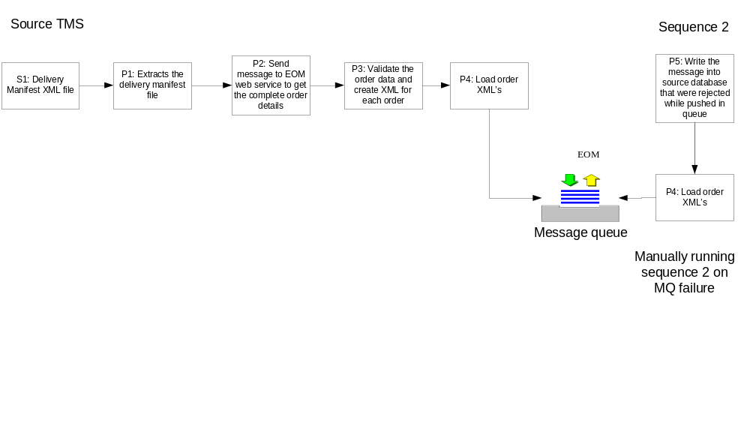

Component | Responsibility
Delivery Manifest XML File Messages | The Source of the interface is the Delivery Manifest xml files from TMS for each store.
Extract the delivery manifest | Extracts the Delivery Manifest xml files for each store and format the messages.
EOM web service | Make a call to EOM web service for each order in a store to get the complete order details.
Create XML message for each order | Create a XML message as per the EOM expected format
Load XML message | Load the XML message created to EOM queue. And capture the reject messages that are not pushed into the queue.
Load reject XML messages | This process will format the rejected messages from the queue and then will reload them again. This process is run manually in case of any failures of the messages.

Integration Flows
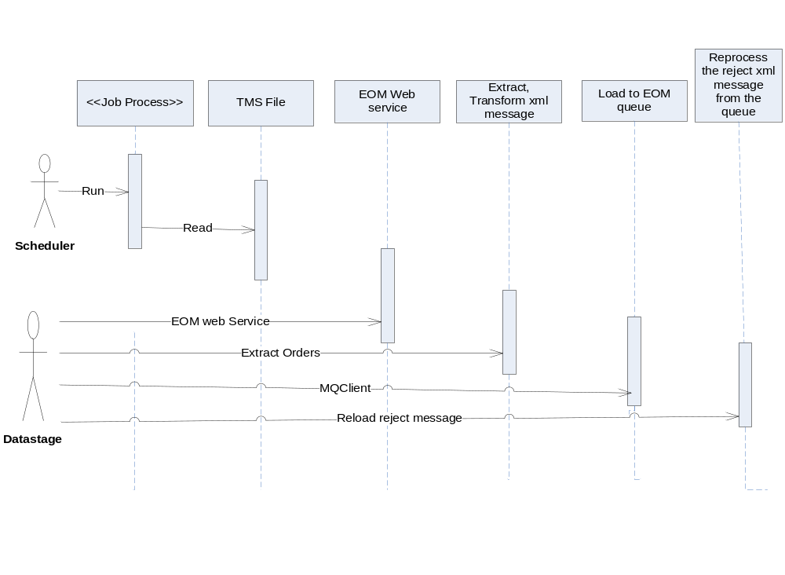

Detailed Component Design

Reads TMS file

This component reads the delivery manifest files from TMS and creates a temporary dataset.

EOM Web service

This component will make a web service call to EOM to get the complete order details like customer information, delivery date and time and order related information. Will also use a new config file with titan store list such that only orders related to those stores are processed.

Transforming and creating XML file
This component transforms the delivery manifest from TMS and Order information from EOM web service to format the EOM can consume and creates a dataset.

Load to EOM queue

This job load the dataset (XML format) created in the above process to EOM queue and also captures the reject messages which are not sent to the queue to a file.

Reprocess reject XML
This job checks for the messages that are not processed and create a dataset that hold the order XML messages that needs to be loaded to the target queue. This job is not part of the main sequence but separate sequence is created to process the failed orders.

Mapping document
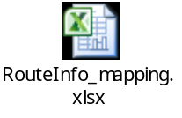

Error Handling Strategy
Error | Expected Behavior and Design details
File system error | Any file system error (not enough space or access issue) will result in job abort. The system will record the error and notify the support personnel.
Webservice error | Any Web service connectivity or access issue will result in job abort. The system will record the error and notify the support personnel.
Queue error | Any MQ connectivity or access issue will result in job abort. The system will record the error and notify the support personnel.

Security
Security Requirement | Design
 | No security requirement

Monitoring
Monitoring | Design
 | No special monitoring required. The job will be triggered via ESP. In case of any error, the appropriate team will be notified by standard ESP alerts.

Administration

Execution Strategy
.
Execution | Design
ESP | There will be an ESP jobs for executing

Recovery Strategy
Recovery | Design
Start from Point of Failure | The design adhere to “start from point of failure” strategy. This means at any point, if the job aborts, it should start from the same place. This will provide the best efficiency even though the design and implementation are more complex.

Housekeeping Strategy
Housekeeping | Design
Delete temp files from temp directory | Temp files will be stored in a temp directory during execution of the job. After which, the temp files will be deleted regardless if the job completed successfully or not.
Delete log files which are more than 15 days old from log directory | All logs pertaining to the job will be stored in a log directory. But, those older than 30 days will be deleted before the job finishes to preserve disk space in the Unix server.

4. IDD Review Comments
Date of Review | Issue | Recommendation/Concern

